**Assignment 5:  
DAC Waveform Generation**

**Cal Poly CPE 329-01**

**Spring 2017**

Brendan Baronia

Melinda Ong

Professor Gerfen, Jeffrey B.

**April 24, 2017**

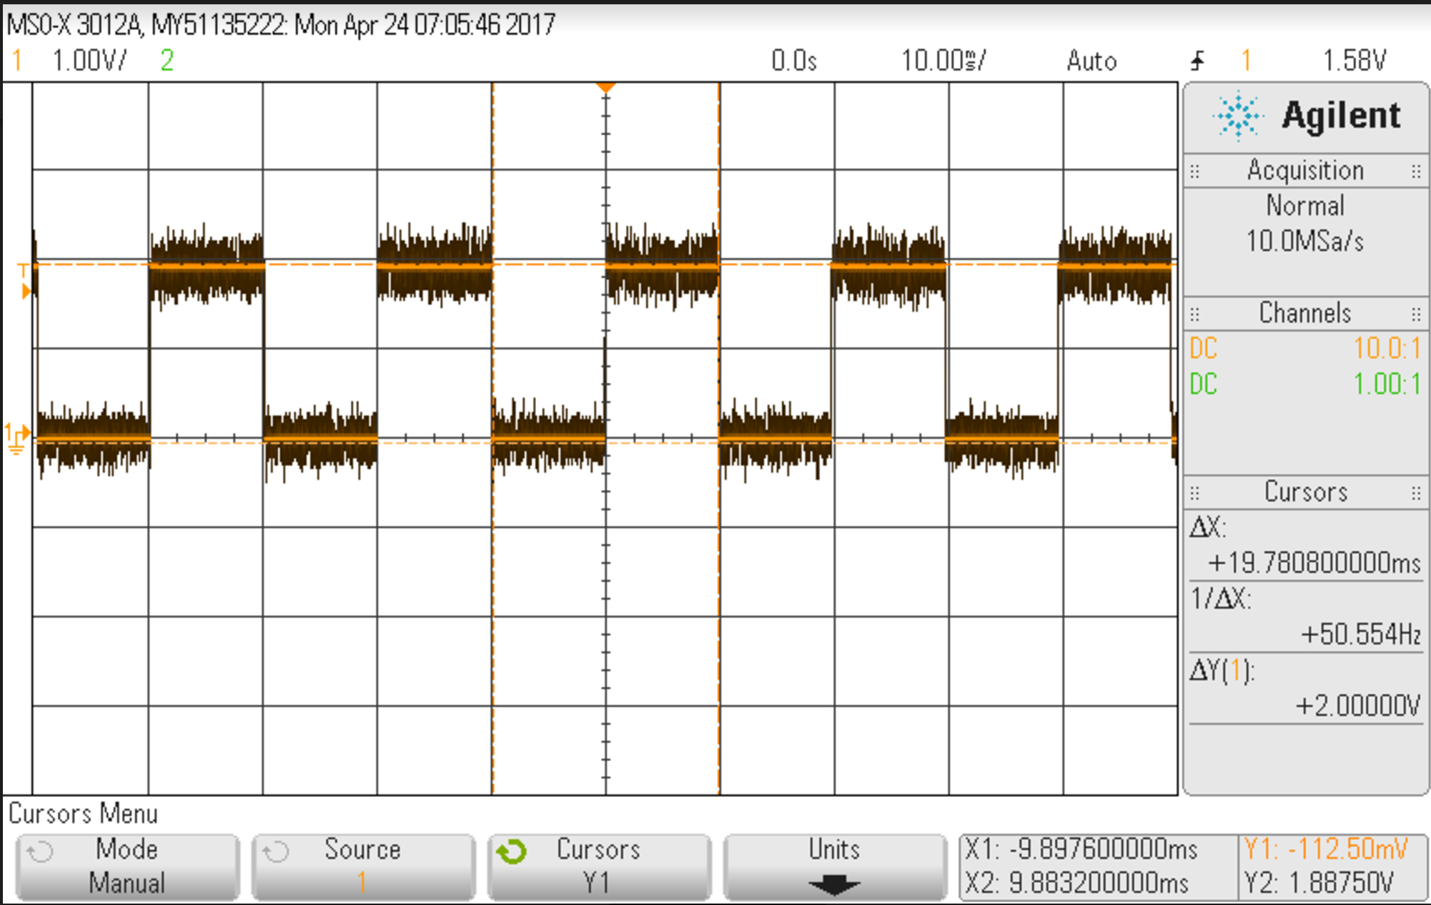

**Figure 1: Screenshot of square wave output on oscilloscope**

***i.) main.c of square wave:***

//*****************************************************************************  
//  
// DriveDAC.C  
//  
//****************************************************************************  
  
#include "msp.h"  
#define CYCLETIMER 30000 //Adjust this for ISR Timer  
#define TempDAC_Value 2482  
  
void Drive_DAC(unsigned int level);  
volatile unsigned int outHigh;  
  
  
int main(void)  
{  
  
 WDT_A->CTL = WDT_A_CTL_PW | WDT_A_CTL_HOLD; // Stop watchdog timer  
  
 // DCO = 24 MHz, SMCLK and MCLK = DCO  
 CS->KEY = CS_KEY_VAL;  
 CS->CTL0 = 0;  
 CS->CTL0 = CS_CTL0_DCORSEL_4; // DCO = 24 MHz  
 CS->CTL1 = CS_CTL1_SELA_2 | CS_CTL1_SELS_3 | CS_CTL1_SELM_3;  
 CS->KEY = 0;  
  
 // Configure port bits for SPI  
 P4->DIR |= BIT1; // Will use BIT4 to activate /CE on the DAC  
 P1SEL0 |= BIT6 + BIT5; // Configure P1.6 and P1.5 for UCB0SIMO and UCB0CLK  
 P1SEL1 &= ~(BIT6 + BIT5); //  
  
 // SPI Setup  
 EUSCI_B0->CTLW0 |= EUSCI_B_CTLW0_SWRST; // Put eUSCI state machine in reset  
  
 EUSCI_B0->CTLW0 = EUSCI_B_CTLW0_SWRST | // Remain eUSCI state machine in reset  
 EUSCI_B_CTLW0_MST | // Set as SPI master  
 EUSCI_B_CTLW0_SYNC | // Set as synchronous mode  
 EUSCI_B_CTLW0_CKPL | // Set clock polarity high  
 EUSCI_B_CTLW0_MSB; // MSB first  
  
 EUSCI_B0->CTLW0 |= EUSCI_B_CTLW0_SSEL__SMCLK; // SMCLK  
 EUSCI_B0->BRW = 0x01; // divide by 16, clock = fBRCLK/(UCBRx)  
 EUSCI_B0->CTLW0 &= ~EUSCI_B_CTLW0_SWRST; // Initialize USCI state machine, SPI  
 // now waiting for something to  
 // be placed in TXBUF  
  
 EUSCI_B0->IFG |= EUSCI_B_IFG_TXIFG; // Clear TXIFG flag  
  
 TIMER_A0->CCTL[0] = TIMER_A_CCTLN_CCIE; // TACCR0 interrupt enabled  
 TIMER_A0->EX0 = 7;  
 TIMER_A0->CCR[0] = CYCLETIMER; //Set CCR0 for on cycle  
  
 TIMER_A0->CTL = TIMER_A_CTL_SSEL__SMCLK | // SMCLK, continuous mode  
 0x10;  
  
  
 // Enable global interrupt  
 __enable_irq();  
  
 NVIC->ISER[0] = 1 << ((TA0_0_IRQn) & 31);  
  
 while (1) {  
 if (outHigh)  
 Drive_DAC(TempDAC_Value);  
 else  
 Drive_DAC(0);  
}  
  
} // end of main  
  
// Timer A0 interrupt service routine  
void TA0_0_IRQHandler(void) {  
 TIMER_A0->CCTL[0] &= ~TIMER_A_CCTLN_CCIFG;  
 outHigh = ~outHigh;  
}  
  
void Drive_DAC(unsigned int level){  
 unsigned int DAC_Word = 0;  
 int i;  
  
 DAC_Word = (0x3000) | (level & 0x0FFF); // 0x1000 sets DAC for Write  
 // to DAC, Gain = 1, /SHDN = 1  
 // and put 12-bit level value  
 // in low 12 bits.  
  
 P4->OUT &= ~BIT1; // Clear P4.1 (drive /CS low on DAC)  
 // Using a port output to do this for now  
  
 EUSCI_B0->TXBUF = (unsigned char) (DAC_Word >> 8); // Shift upper byte of DAC_Word  
 // 8-bits to right  
  
 while (!(EUSCI_B0->IFG & EUSCI_B_IFG_TXIFG)); // USCI_A0 TX buffer ready?  
  
 EUSCI_B0->TXBUF = (unsigned char) (DAC_Word & 0x00FF); // Transmit lower byte to DAC  
  
 while (!(EUSCI_B0->IFG & EUSCI_B_IFG_TXIFG)); // Poll the TX flag to wait for completion  
  
 for(i = 200; i > 0; i--); // Delay 200 16 MHz SMCLK periods  
 //to ensure TX is complete by SIMO  
  
 P4->OUT |= BIT1; // Set P4.1 (drive /CS high on DAC)  
  
 return;  
}

***ii.) main.c of triangle wave***

//*****************************************************************************  
//  
// DriveDAC.C  
//  
//****************************************************************************  
  
#include "msp.h"  
#define CYCLETIMER 30000 //Adjust this for ISR Timer  
#define TempDAC_Value 2482  
  
void Drive_DAC(unsigned int level);  
volatile unsigned int outHigh;  
  
  
int main(void)  
{  
  
 WDT_A->CTL = WDT_A_CTL_PW | WDT_A_CTL_HOLD; // Stop watchdog timer  
  
 // DCO = 24 MHz, SMCLK and MCLK = DCO  
 CS->KEY = CS_KEY_VAL;  
 CS->CTL0 = 0;  
 CS->CTL0 = CS_CTL0_DCORSEL_4; // DCO = 24 MHz  
 CS->CTL1 = CS_CTL1_SELA_2 | CS_CTL1_SELS_3 | CS_CTL1_SELM_3;  
 CS->KEY = 0;  
  
 // Configure port bits for SPI  
 P4->DIR |= BIT1; // Will use BIT4 to activate /CE on the DAC  
 P1SEL0 |= BIT6 + BIT5; // Configure P1.6 and P1.5 for UCB0SIMO and UCB0CLK  
 P1SEL1 &= ~(BIT6 + BIT5); //  
  
 // SPI Setup  
 EUSCI_B0->CTLW0 |= EUSCI_B_CTLW0_SWRST; // Put eUSCI state machine in reset  
  
 EUSCI_B0->CTLW0 = EUSCI_B_CTLW0_SWRST | // Remain eUSCI state machine in reset  
 EUSCI_B_CTLW0_MST | // Set as SPI master  
 EUSCI_B_CTLW0_SYNC | // Set as synchronous mode  
 EUSCI_B_CTLW0_CKPL | // Set clock polarity high  
 EUSCI_B_CTLW0_MSB; // MSB first  
  
 EUSCI_B0->CTLW0 |= EUSCI_B_CTLW0_SSEL__SMCLK; // SMCLK  
 EUSCI_B0->BRW = 0x01; // divide by 16, clock = fBRCLK/(UCBRx)  
 EUSCI_B0->CTLW0 &= ~EUSCI_B_CTLW0_SWRST; // Initialize USCI state machine, SPI  
 // now waiting for something to  
 // be placed in TXBUF  
  
 EUSCI_B0->IFG |= EUSCI_B_IFG_TXIFG; // Clear TXIFG flag  
  
 TIMER_A0->EX0 = 7;  
 TIMER_A0->CCR[0] = CYCLETIMER; //Set CCR0 for on cycle  
  
 TIMER_A0->CTL = TIMER_A_CTL_SSEL__SMCLK | // SMCLK, continuous mode  
 0x30;  
  
 while (1) {  
 unsigned int timerCount = TIMER_A0 -> R; //set to current time  
  
 unsigned int DACval = (timerCount * TempDAC_Value) / CYCLETIMER;  
 Drive_DAC (DACval);  
}  
  
} // end of main  
  
  
void Drive_DAC(unsigned int level){  
 unsigned int DAC_Word = 0;  
 int i;  
  
 DAC_Word = (0x3000) | (level & 0x0FFF); // 0x1000 sets DAC for Write  
 // to DAC, Gain = 1, /SHDN = 1  
 // and put 12-bit level value  
 // in low 12 bits.  
  
 P4->OUT &= ~BIT1; // Clear P4.1 (drive /CS low on DAC)  
 // Using a port output to do this for now  
  
 EUSCI_B0->TXBUF = (unsigned char) (DAC_Word >> 8); // Shift upper byte of DAC_Word  
 // 8-bits to right  
  
 while (!(EUSCI_B0->IFG & EUSCI_B_IFG_TXIFG)); // USCI_A0 TX buffer ready?  
  
 EUSCI_B0->TXBUF = (unsigned char) (DAC_Word & 0x00FF); // Transmit lower byte to DAC  
  
 while (!(EUSCI_B0->IFG & EUSCI_B_IFG_TXIFG)); // Poll the TX flag to wait for completion  
  
 for(i = 200; i > 0; i--); // Delay 200 16 MHz SMCLK periods  
 //to ensure TX is complete by SIMO  
  
 P4->OUT |= BIT1; // Set P4.1 (drive /CS high on DAC)  
  
 return;  
}